

***LABORATORY PRACTICE - IV***

Group Members :

1. Kunal Desai (24134)
2. Mayur Kharmate (24131)
3. Aniket Uttekar (24130)
4. Shreyas Kulkarni (24129)

**Online Cab Booking V-CAB**

# Title

Mini-Project 2:

Create a small web-based application by selecting relevant system environment/platform and programming languages. Narrate concise Test Plan consisting of features to be tested and bug taxonomy. Narrate scripts to perform regression tests. Identify the bugs using Selenium WebDriver , IDE and generate test reports encompassing exploratory testing.

# Problem Definition

Perform Web testing and identify the bugs using Selenium WebDriver and IDE and generate test reports encompassing exploratory testing.

# Prerequisite

Basic Concepts of Unit Testing, Test Cases Writing using selenium etc tool

# Software Requirements

HTML, CSS, JAVA , SELENIUM ,PYTHON

# Hardware Requirement

2GB RAM, 500 GB HDD, i5 Processor

# Learning Objectives

We are going to learn how to Identify the bugs using Selenium WebDriver and IDE and generate test reports encompassing exploratory testing.

# Theory

### What is Selenium?

Selenium is a free (open source) automated testing suite for web applications across different browsers and platforms. Selenium is a suite of software tools to automate Web Browsers.• It is an Open-source suite of tools mainly used for Functional and Regression Test Automation. Selenium is a free (open source) automated testing suite for web applications across different browsers and platforms.

It is quite similar to HP Quick Test Pro (QTP now UFT) only that Selenium focuses on automating web-based applications. Testing done using Selenium tool is usually referred to as Selenium Testing

* Selenium supports various Operating environments.
  + Microsoft Windows
  + Linux
  + Macintosh
* Selenium supports various Browsers.
  + Mozilla Firefox
  + IE
  + Google Chrome
  + Safari
  + Opera etc…
* Selenium supports various programming environments to write programs (Test scripts)
  + Java
  + C#
  + Python
  + Perl
  + Ruby
  + PHP

### History of the Selenium Project

Selenium first came to life in 2004.

* In 2006, Selenium WebDriver was launched at Google.
* In 2008, the whole Selenium team decided to merge Selenium WebDriver with Selenium RC to form a more powerful tool called Selenium 2.0
  + Selenium 1
    - (Selenium IDE + Selenium RC + Selenium Grid)
  + Selenium 2
    - (Selenium IDE + Selenium RC + Selenium WebDriver + Selenium Grid)

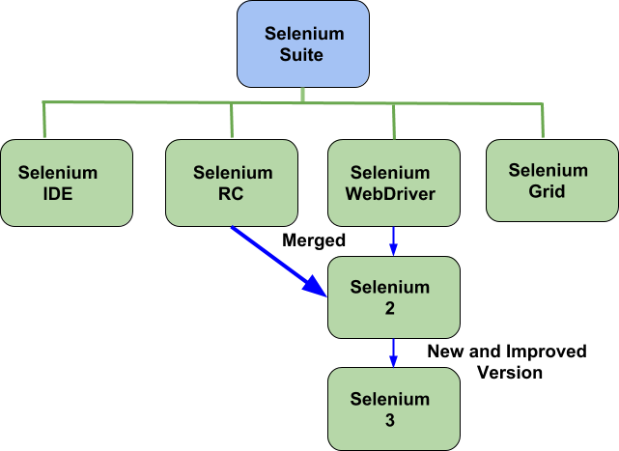

#### Selenium’ Tools Suite :-

Selenium is not just a single tool but a suite of software's, each catering to different testing needs of an organization. It has four components.

* + Selenium Integrated Development Environment (IDE)
  + Selenium Remote Control (RC)
  + WebDriver
  + Selenium Grid

##### Selenium IDE Features :-

* + Create Test Cases, Test suites (We can Record test cases or type Test steps using element locators and Selenese commands)
  + Edit Test Cases
  + Execute Test cases, Test suites
  + Debug Test Cases.
  + Enhance Test Cases

##### Drawbacks of Selenium IDE :-

* + It supports Mozilla Firefox browser only.
  + It doesn’t support Programming logic/features to enhance Test cases.
  + It doesn’t support Data-Driven Testing.
  + It is not suitable for complex test case design.
  + No centralized maintenance of Objects/Elements

#### Selenium Remote Control (Selenium RC) :-

Selenium RC was the flagship testing framework of the whole Selenium project for a long time.

This is the first automated web testing tool that allowed users to use a programming language

they prefer. As of version 2.25.0, RC can support the following programming languages:

* + **J**ava
* C#
* PHP
* Python
* Perl
* Ruby

#### Selenium WebDriver :-

* It is a Programming interface to create and execute Test cases.
* Selenium IDE has IDE but doesn’t have Programming interface.
* Selenium WebDriver has Programming interface but doesn’t have IDE.
* It communicates directly to the browser.
* No need of Separate Server such as RC ServerUFT/QTP has both IDE as well as a Programming interface.
* Faster Execution than IDE & RC
* Selenium WebDriver supports various programming environments to write programs.

1. Java
2. C#
3. Perl
4. Python
5. Ruby
6. PHP

* Using Element/Object locators/properties and Webdriver Methods we can create and execute Test cases.
* Selenium Webdriver supports various browsers to create and execute a test case/test script/test

Note: Browser driver varies from one browser to another.

* *Drawbacks of Selenium WebDriver*
  + It doesn’t generate detailed Test Reports.
  + No centralized maintenance of Object/elements
  + It requires Programming Knowledge
  + Cannot support the readily new browser
  + Installation is More Complicated than Selenium IDE
  + No built-in mechanism for logging runtimemessage

#### Selenium Grid :-

* Selenium Grid is used to execute tests across multiple browsers, operating environments and machines in parallel.
* Selenium Grid 2 supports Selenium RC Tests as well as Selenium WebDriver Tests.

1. Selenium WebDriver to create Test cases using Element locators and Webdriver methods.
2. Java Programming to enhance test cases.
3. TestNG Framework to group test cases, execute test batches and generate detailed test reports.

* Features:
* Enables simultaneous running of tests in multiple browsers and environments.
* Saves time enormously.
* Utilizes the hub-and-node concept. The hub acts as a central source of Selenium commands to each node connected to it.

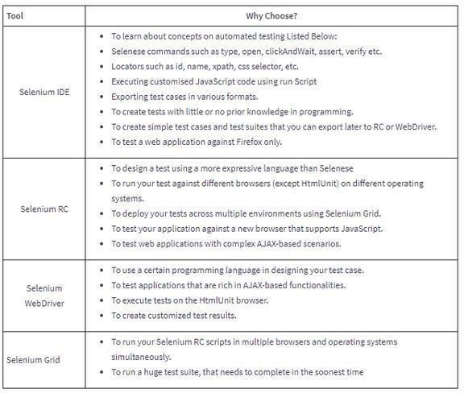

1. **TEST PLAN**

**Introduction :-**

Testing the Attendance Marking system application. **Goals:** To provide platform for online attendance system **Objectives:** Provide platform for taking attendance

## Configuration Management Plan :-

|  |  |
| --- | --- |
| **Stakeholders** | **Tasks** |
| Kunal Desai | Unit Testing |
| Mayur Kharmate | Integration Testing |
| Aniket Uttekar | Alpha Testing |
| Developer | Resolving the Bugs and deploying patches |
| Customer | Beta Testing |

**Features to be tested :-**

* + Login
  + Sign Up
  + Book Cab
  + Check Availability

## Approach :-

* + Unit Testing
  + Integration Testing
  + Acceptance Testing
  + Alpha Testing
  + Beta Testing

## Item Pass/Fail Criteria :-

* + **Evaluation Team** - This subsection describes the job responsibilities and possibly the names of those on the evaluation team.
  + **Exit Criteria** - Defines when to stop testing.
  + **Evaluation Process** - Describes the four steps of the evaluation process to be followed.
  + **Requirements Traceability Matrix** - Describes the process to record and track incidents back to requirements

## Suspension Criteria and Resumption Requirements :-

* + Specify criteria to be used to suspend the testing activity.
  + Specify testing activities which must be redone when testing is resumed.

## Test Deliverables :-

* + Test Cases
  + Test Scripts
  + Defect Reports
  + Test Reports

## Test Environment :-

### Environment

Windows 10 Chromedriver Selenium Apache Tomcat

### Programming Languages HTML

CSS JAVA

### Servlet

* + Testing tool used selenium

## Test Case Scenarios :-

|  |  |  |  |  |  |
| --- | --- | --- | --- | --- | --- |
| **Sr No** | **Input** | **Description** | **Expected Result** | **Actual Result** | **Status** |
| 1 | !abcupgmail.com | Email should be in proper  format | Email is in wrong format | Email is not accepted | Pass |
| 2 | Signup | After signup information should be stored in database and  redirected to login page | Data should be inserted in database and redirected to login page | Data is inserted and page is redirected to login page | Pass |
| 3 | login | If credentials provided are correct then it should be  redirected to | Page should redirected to Profile page if credentials matched | Page should redirected to login page if credentials matched and | Pass |

|  |  |  |  |  |  |
| --- | --- | --- | --- | --- | --- |
|  |  | Profile Page | Otherwise it display the message that  <Invalid  credentials= | Otherwise it display the message that  <Invalid  credentials= |  |
| 4 | Empty field validation | Empty input should not be accepted | If field is empty form should not be submitted | If field is empty form should not be submitted | Pass |
| 5 | Password | Password length should be greater than Or equal to 8 | Password length less than 8 digits should not be accepted | Password length less than 8 digits should not be accepted | Pass |
| 6 | Book Cab | When user book a cab then request should be sent to driver | Request sent to driver | Request sent to driver | Pass |
| 7 | Check Availability | When user search for a cab and if it is available then information of available cab should be displayed | If cab available then information of cab should be displayed otherwise it should displayed the message <no cabs are  available= | If cab available then information of cab should be displayed otherwise it should displayed the message <no cabs are  available= | Pass |

**Setting up Selenium :-**

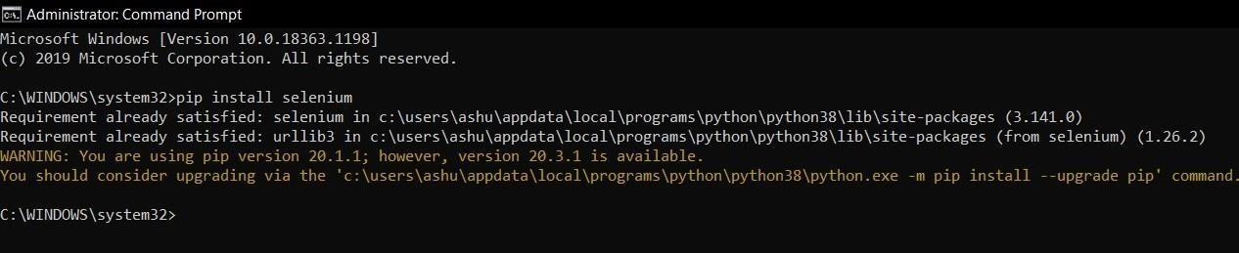Use pip to install the selenium package . Python 3.6 has pip available in the standard library. Using pip ,you can install selenium like this :- **pip install selenium**

## Setting up Chromedriver :-

1. **Install chocolatey :-**

Visit official website of chocolatey <https://chocolatey.org/>

**Steps to Install Chocolatey :-**

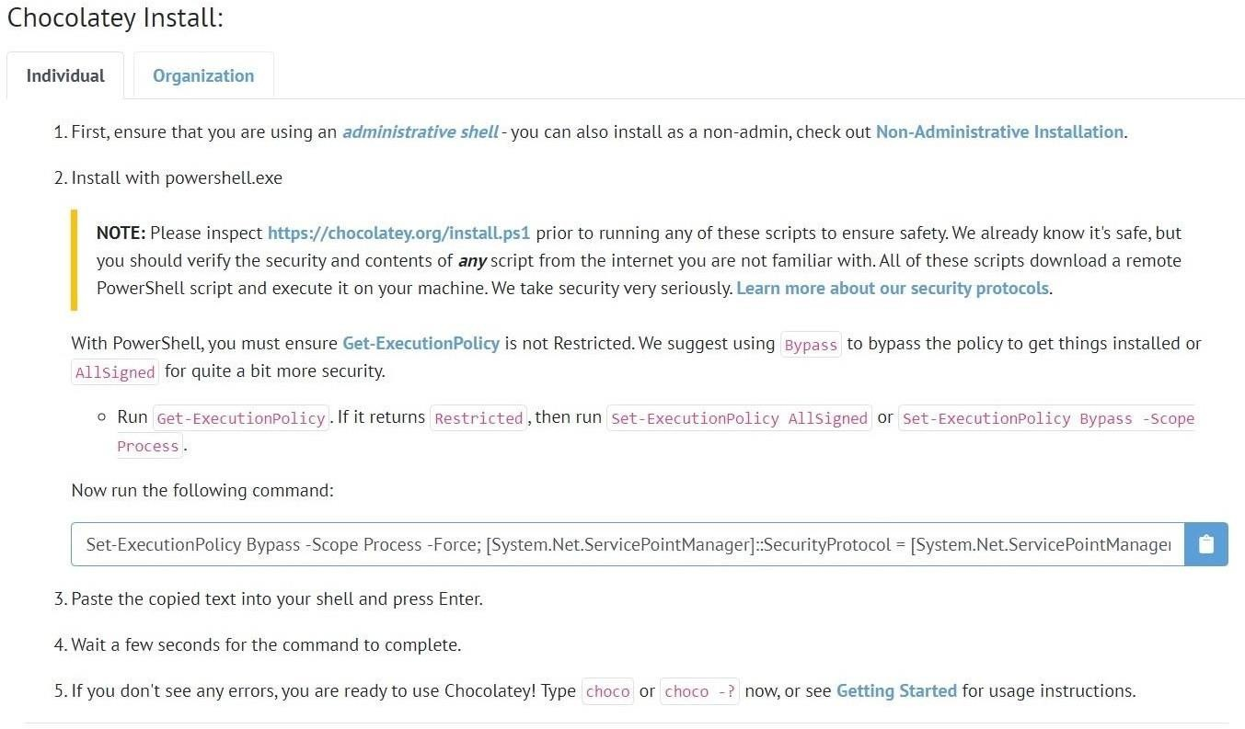

## Install Chromedriver :-

**choco install chromedriver**

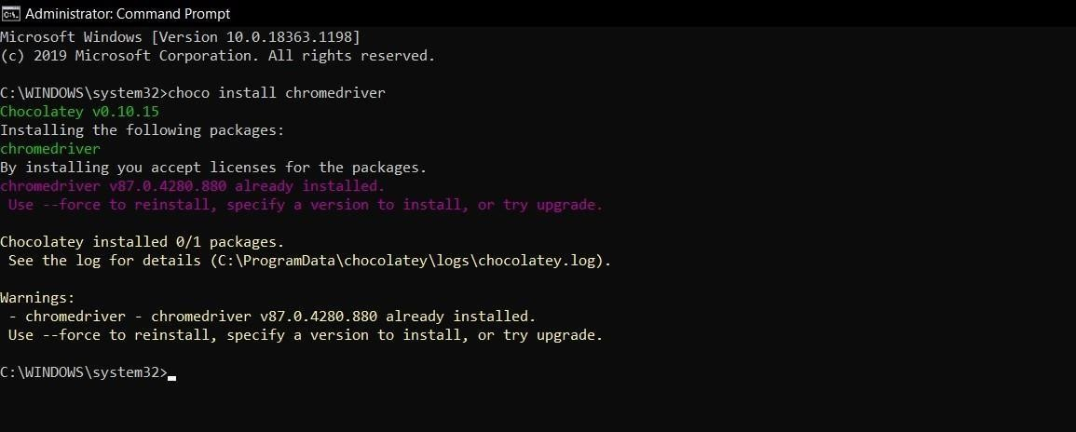

## Selenium Testing Using Webdriver :-

Use the Selenium with ChromeDriver the Corresponding Package has to be included before initializing .

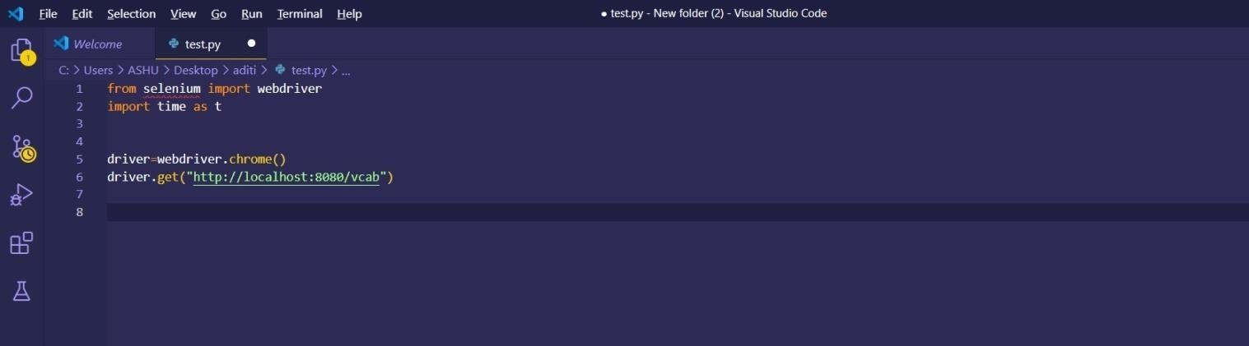

**Testing the login functionality :-**

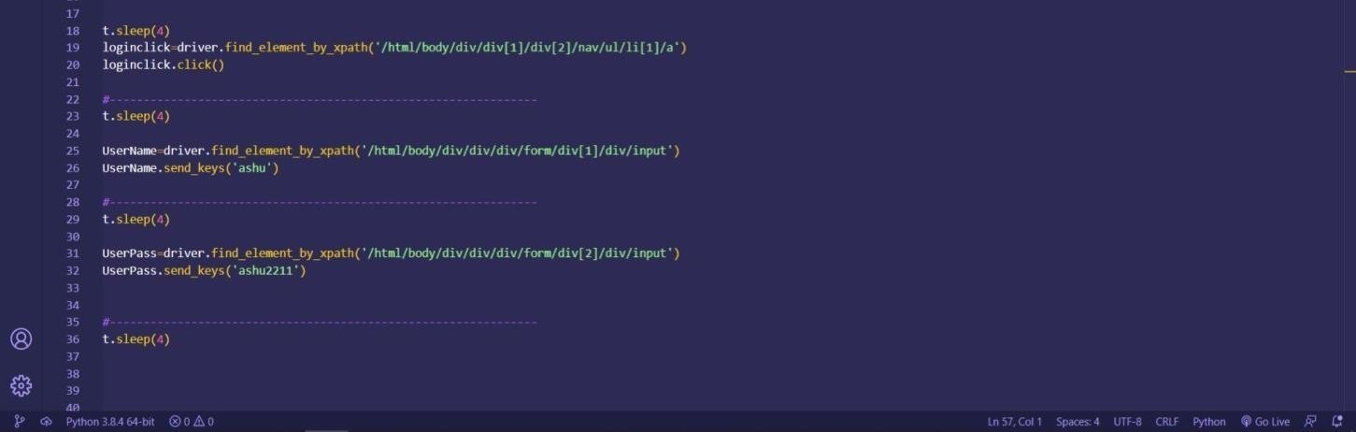

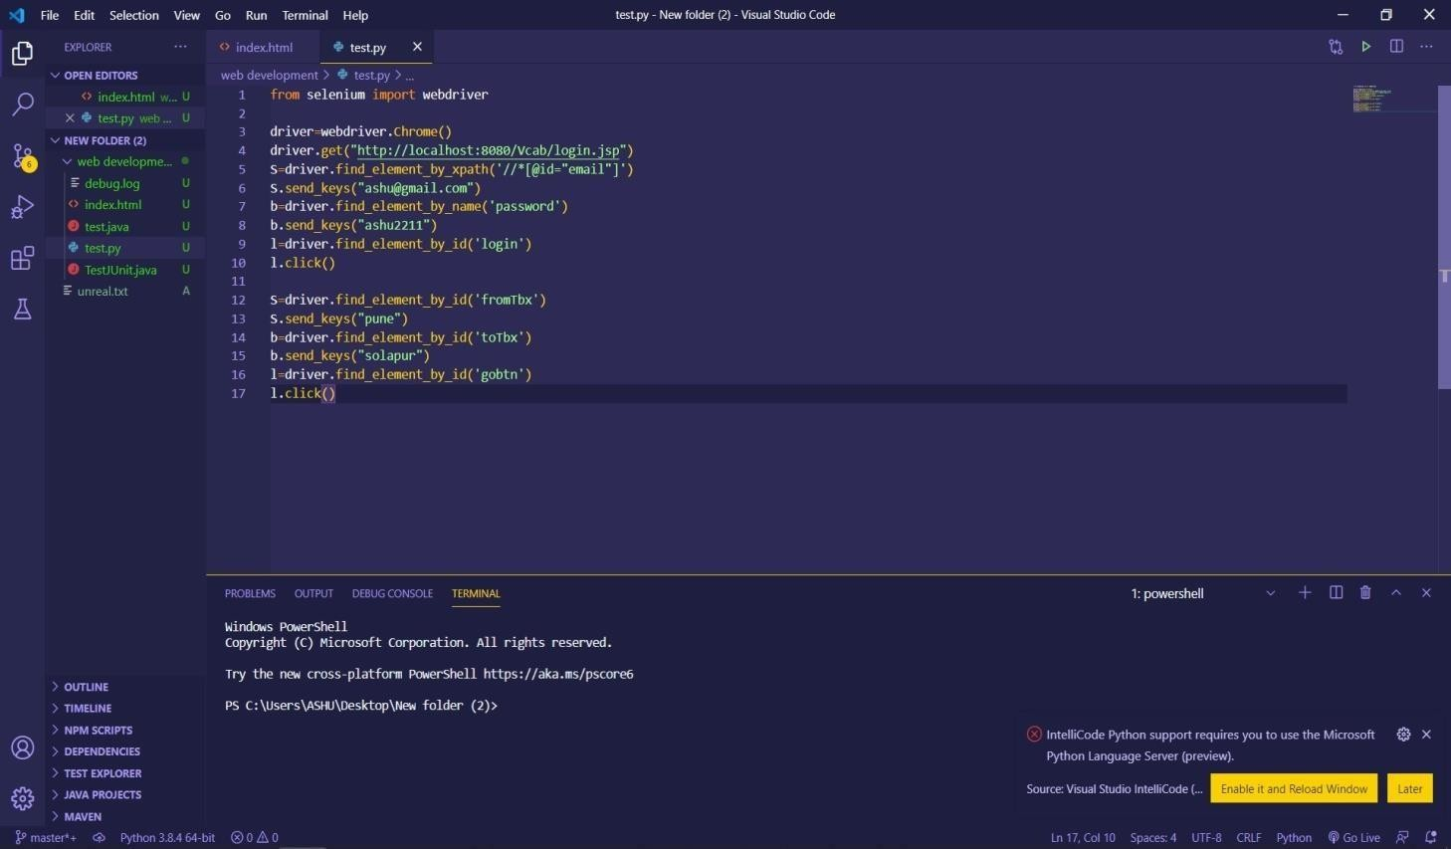

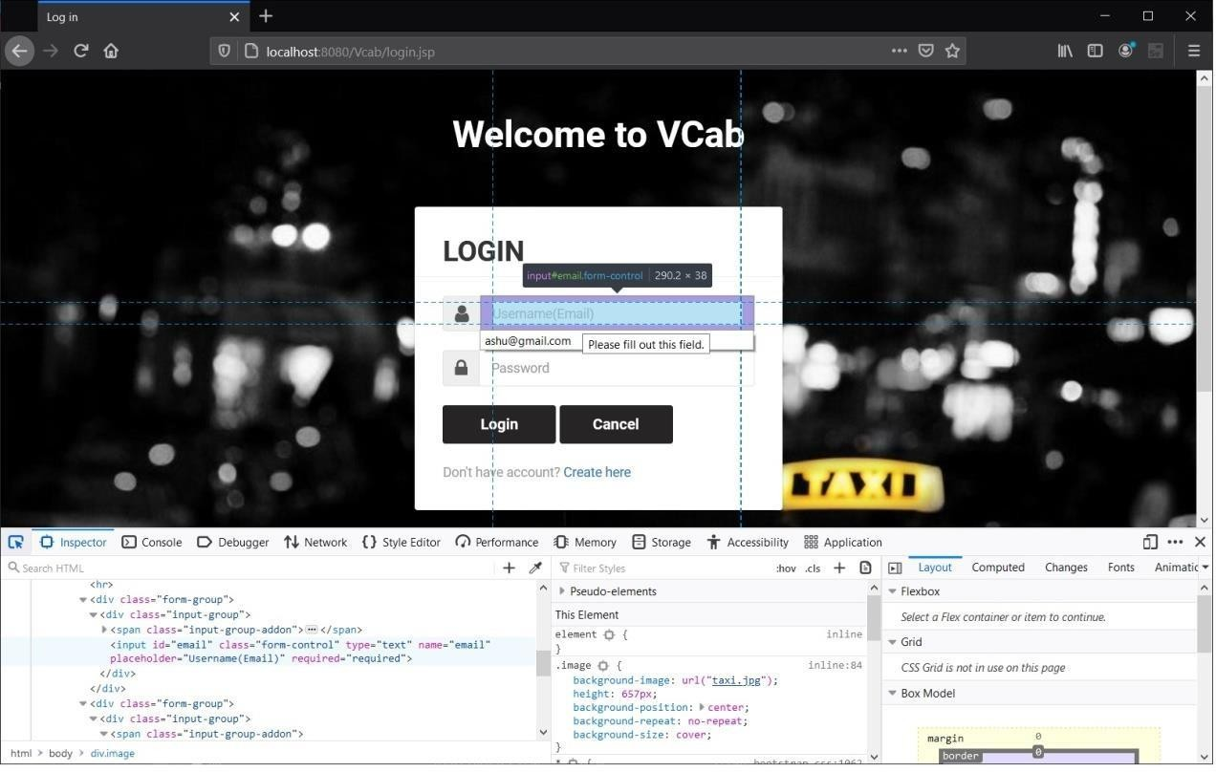

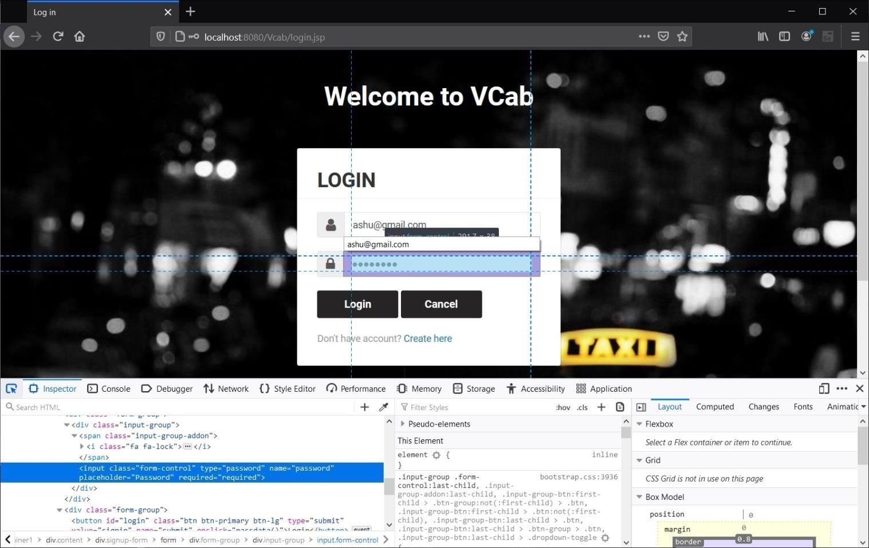

**Testing Using Selenium IDE :-**

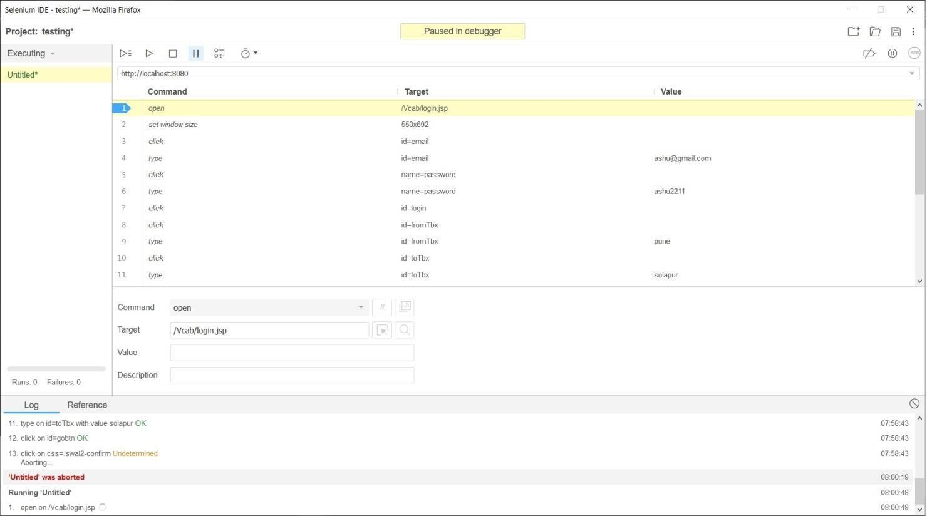

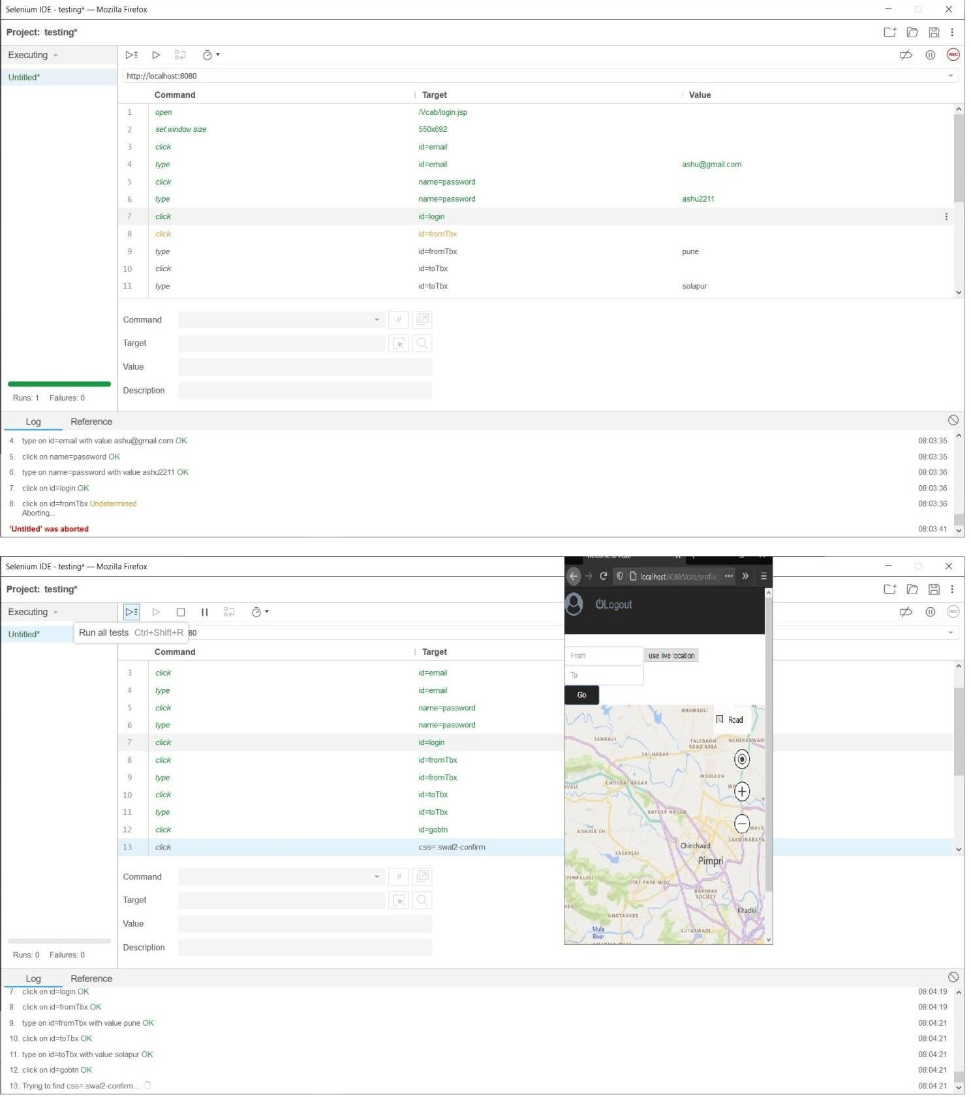

**Program :-**

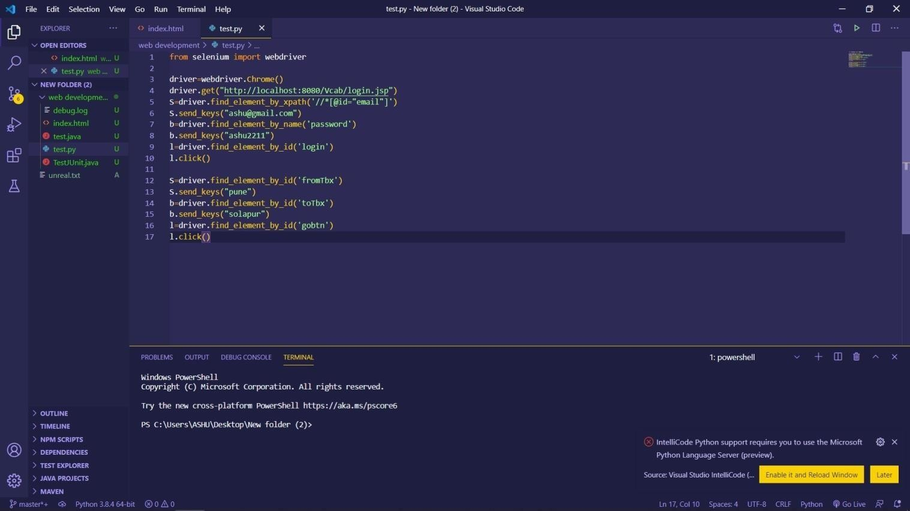

**Conclusion :-**

In this way using the Selenium we have Perform Testing and Prepared Test Report of the same.